WIT IDC Hackathon

I developed Family Application for Android Platform in Kotlin. Where each family have GroupID associated with it

There are many features

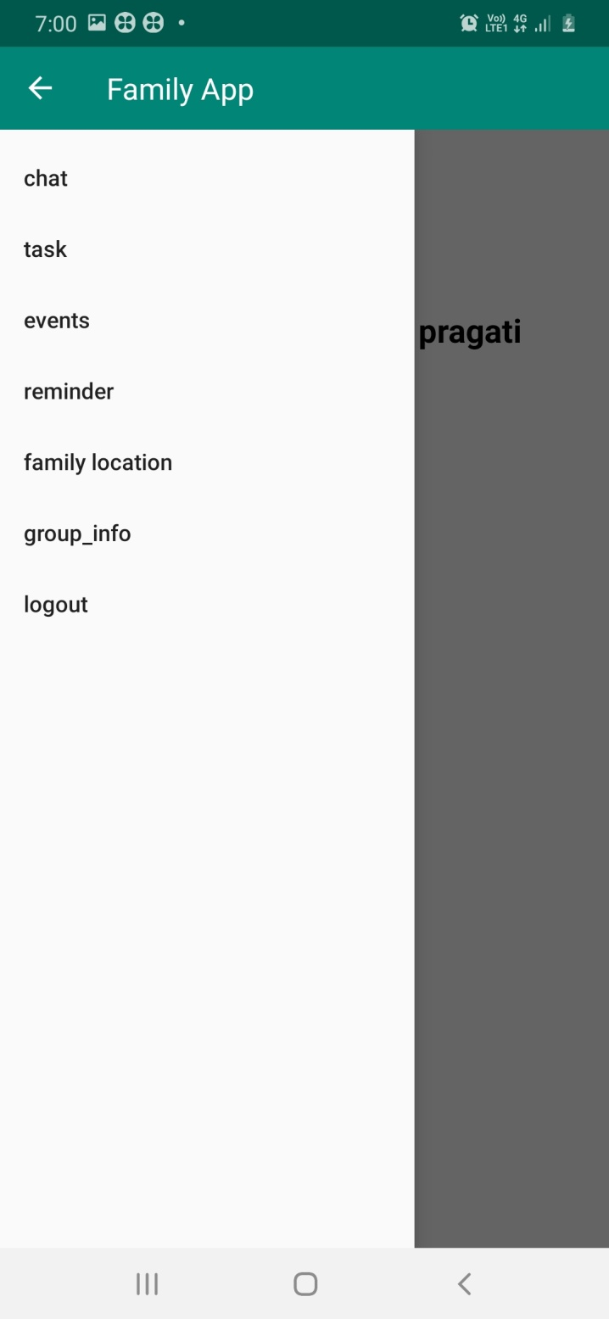

I implemented 4 fetaures

1. Login

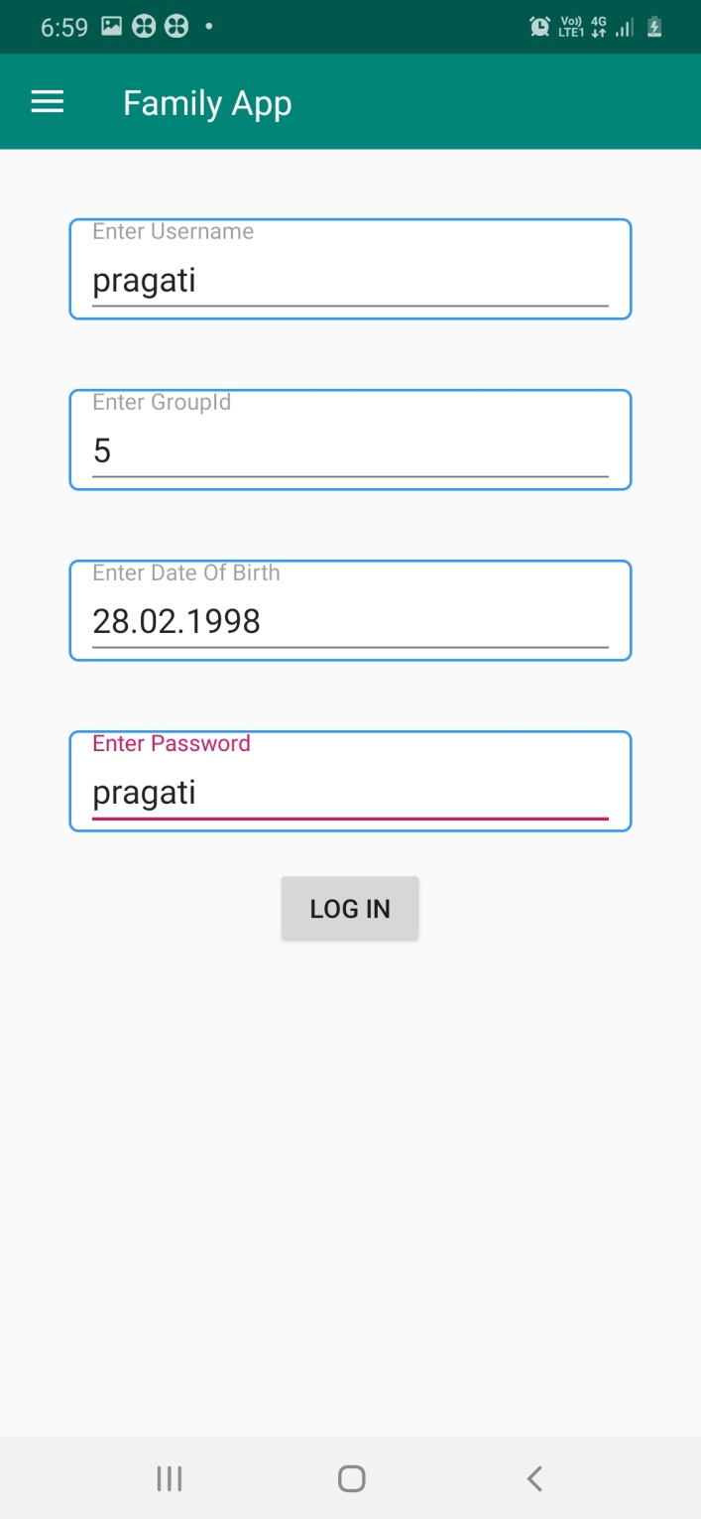

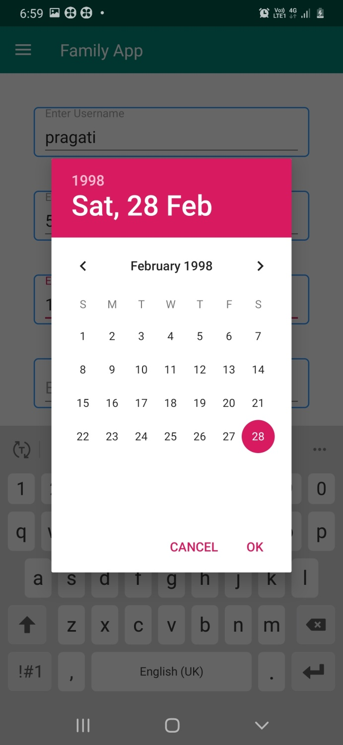

After login User Data save to local Database using Room.

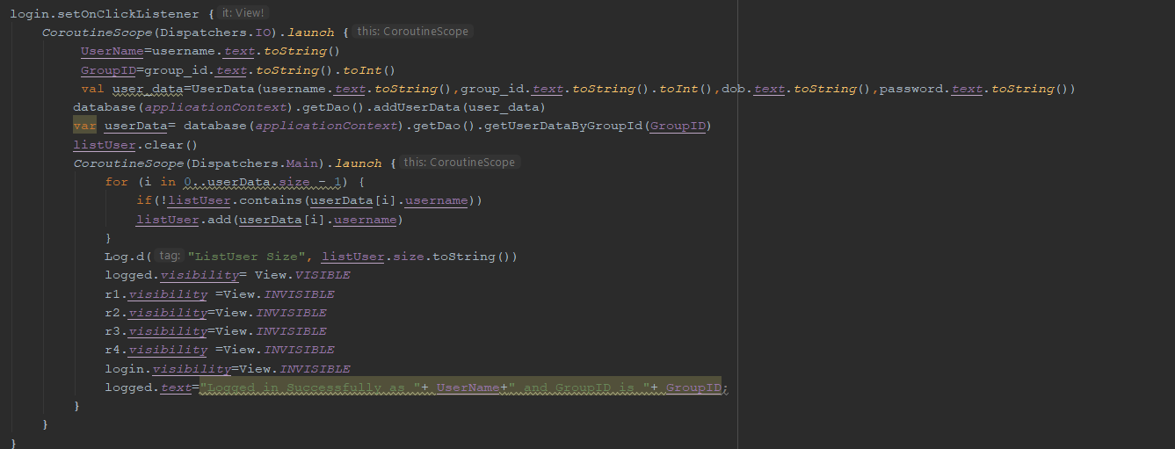

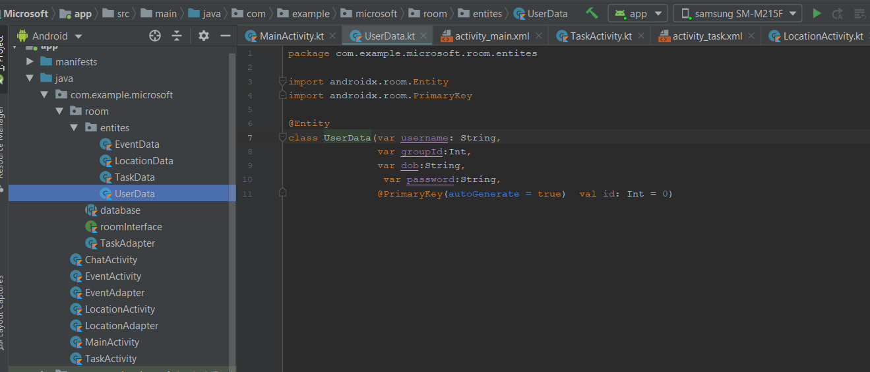

After Login Successfully

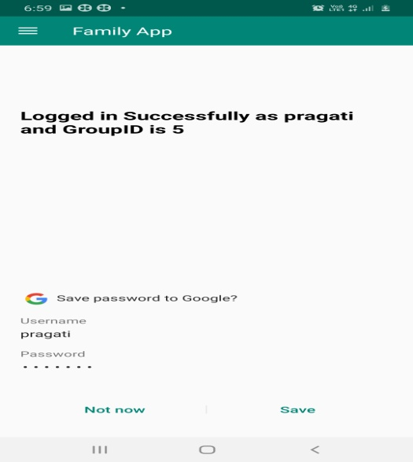

1. Events:- User can add any event for family

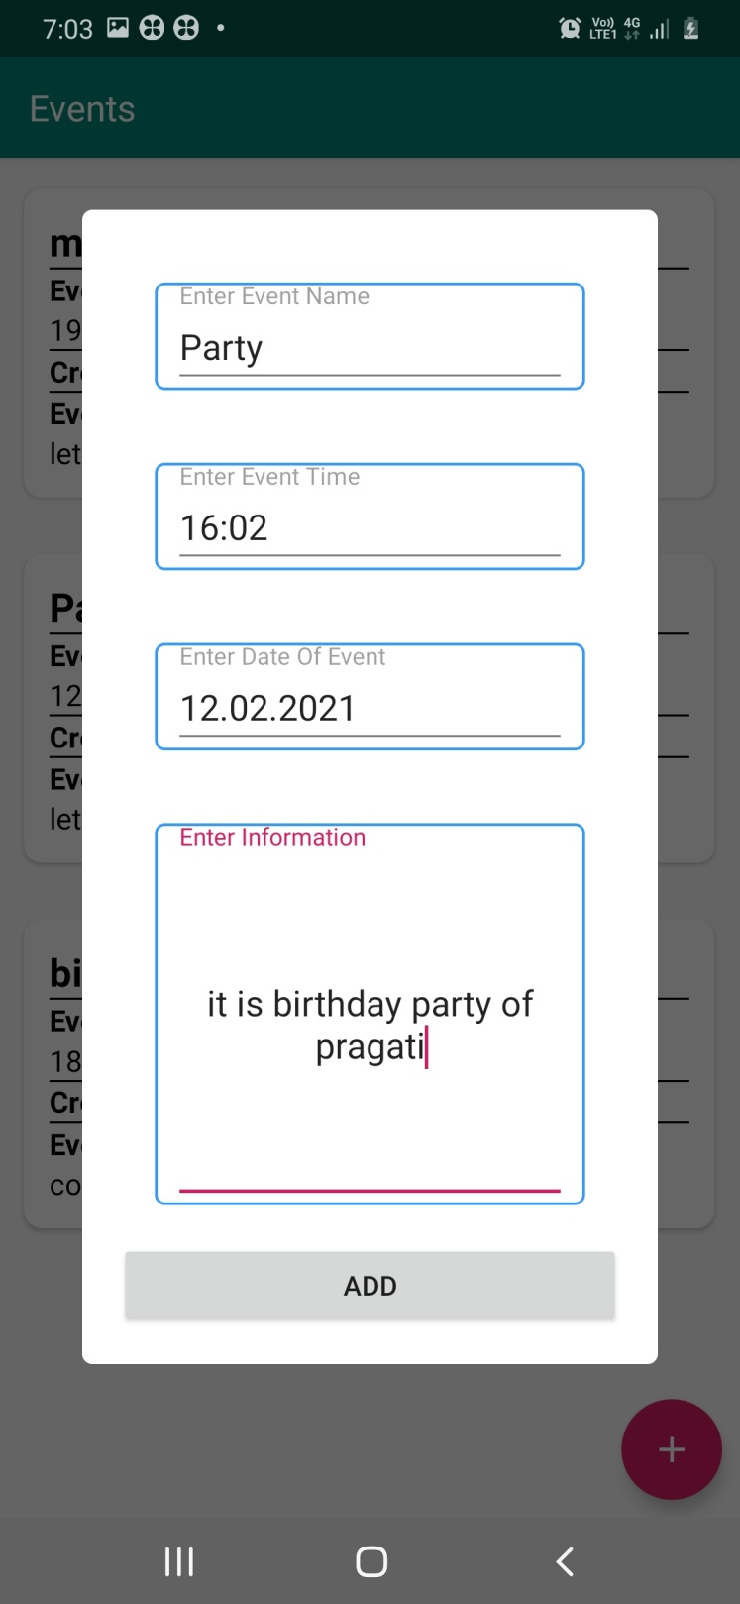

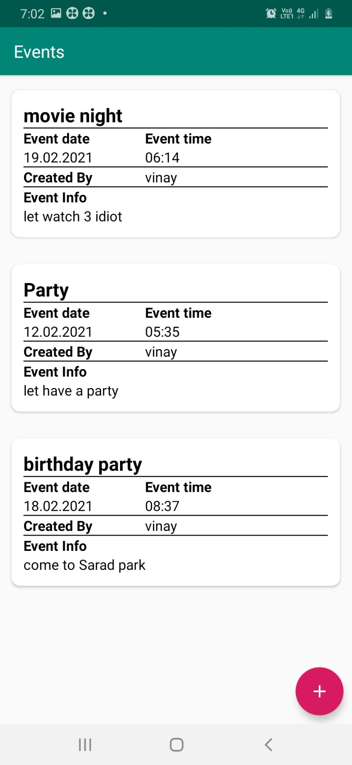

Store Event Data

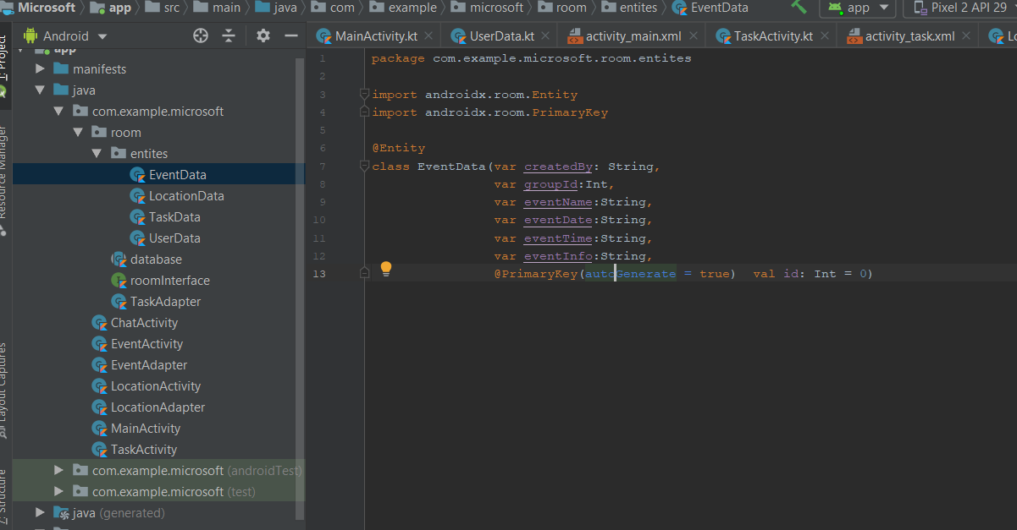

1. Task:- Any family member can assign task to any other or himself also.

Task is divided into 2 parts

1. Task Created By User
2. Task Assigned To User

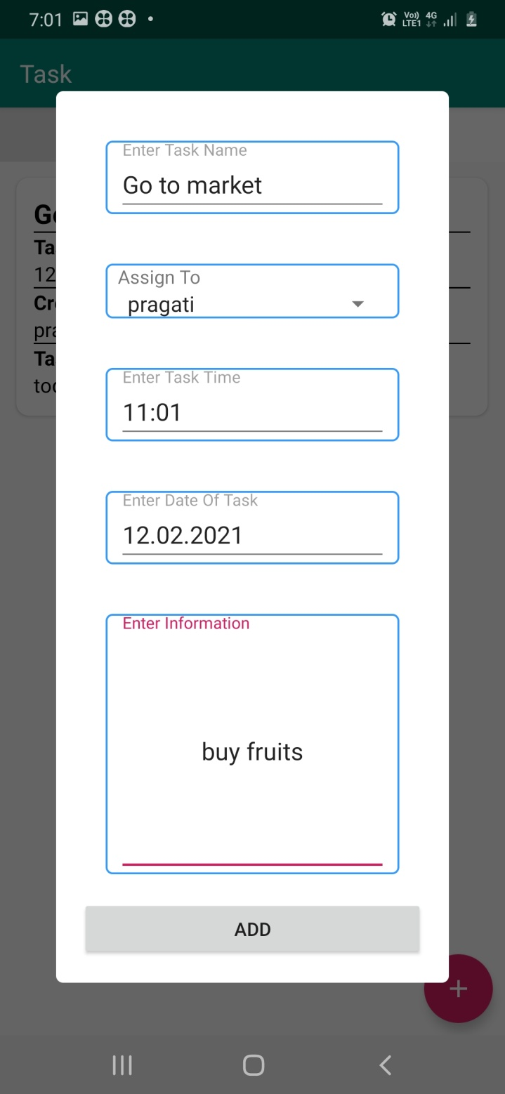

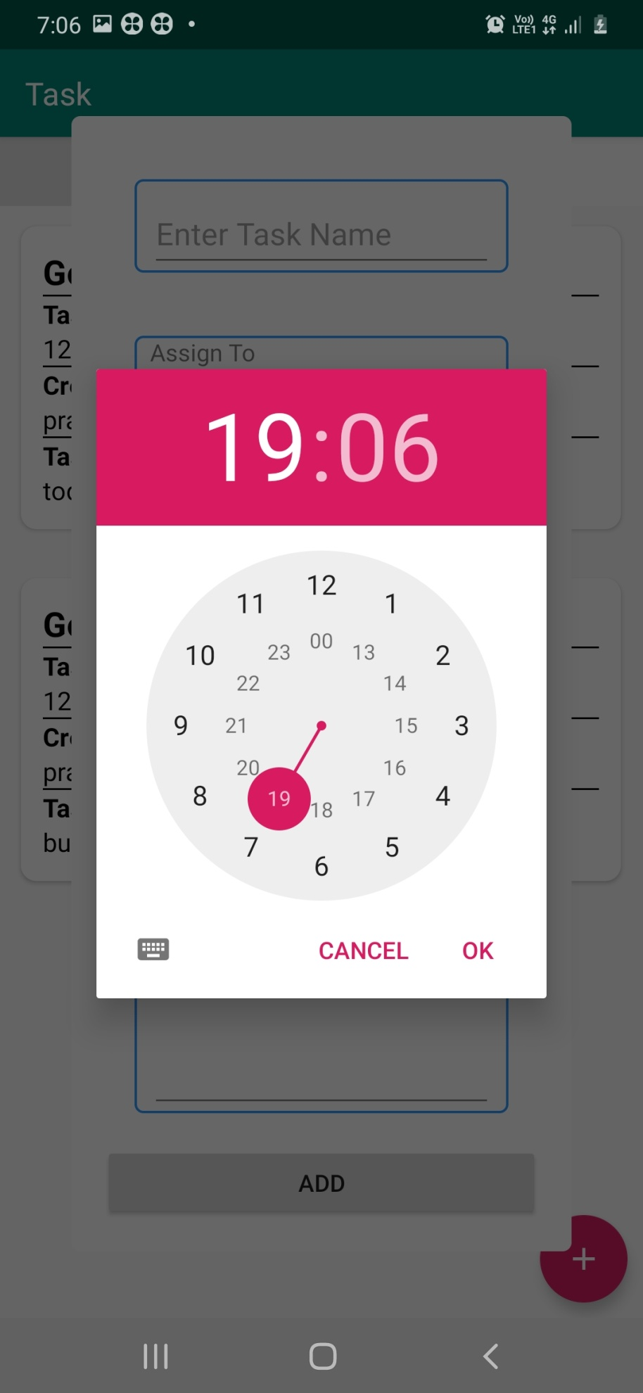

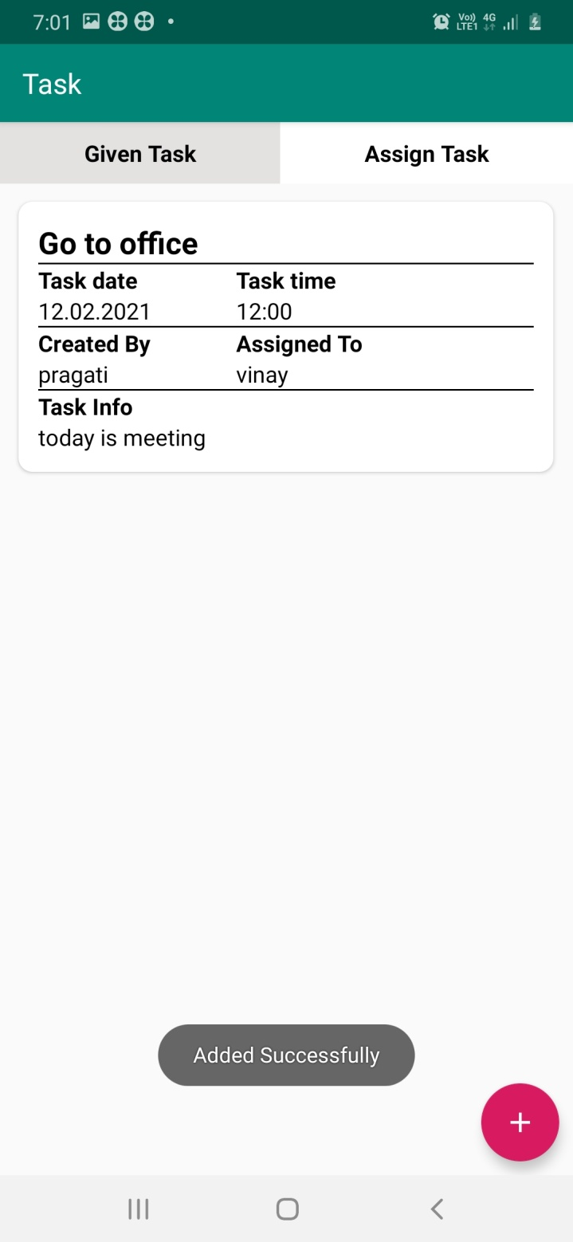

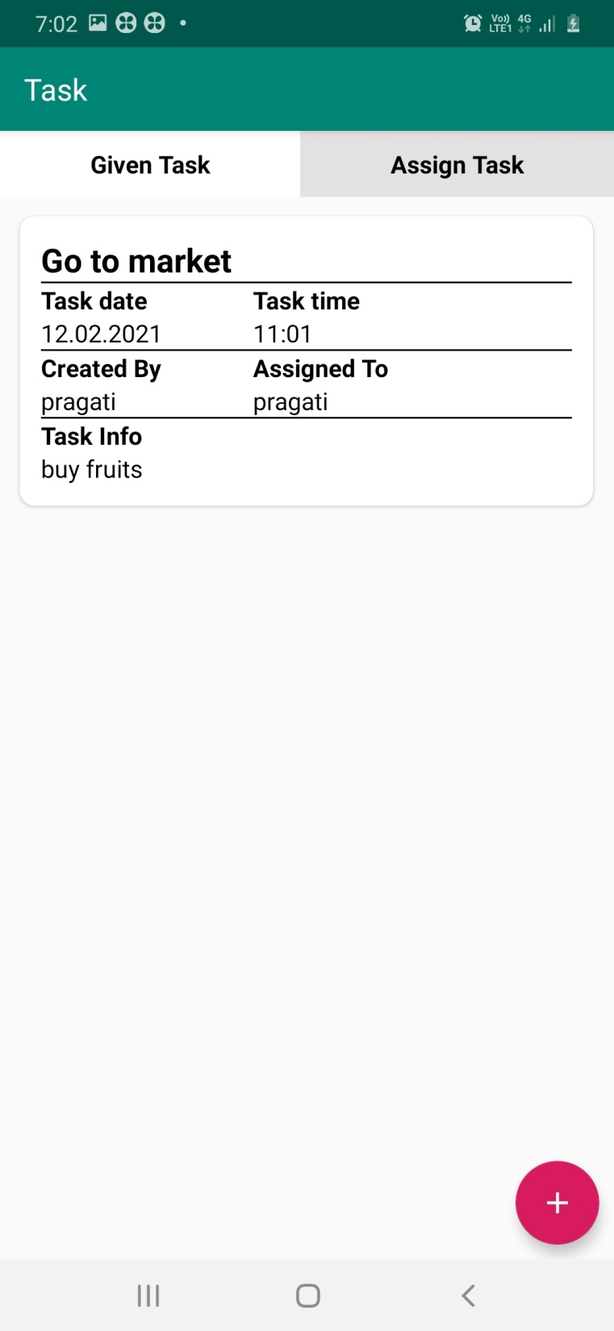

Store User Task Data

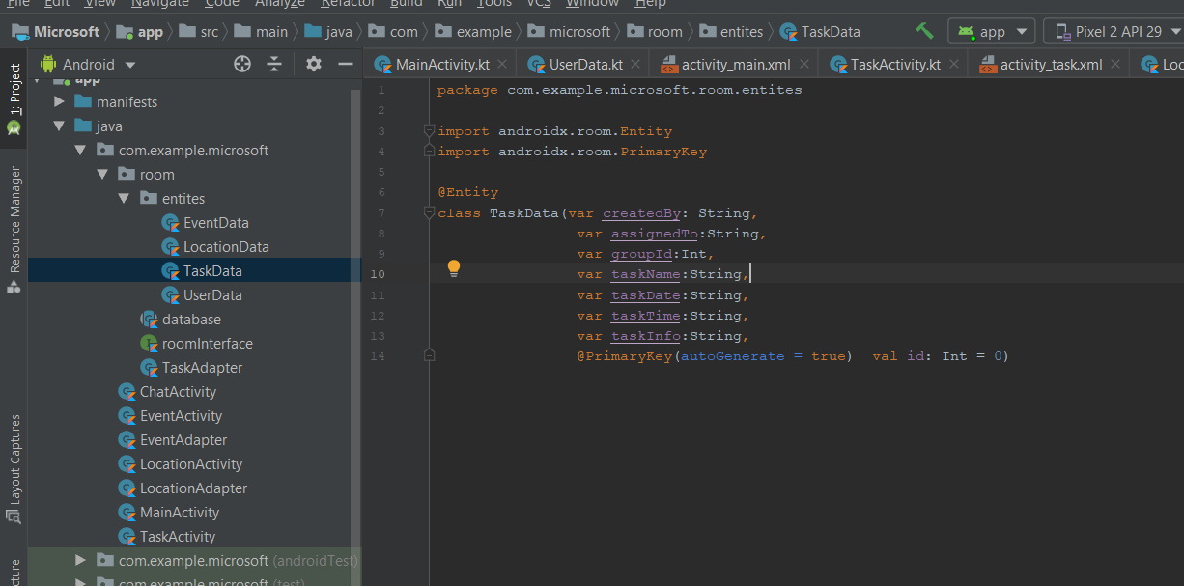

1. Family Location :- There user can allow or Deny permission to access Location.

There User can see his family members last location and last date and last time who grant permission, if user grant access to his/her location he/she can also

see distance from their family members.

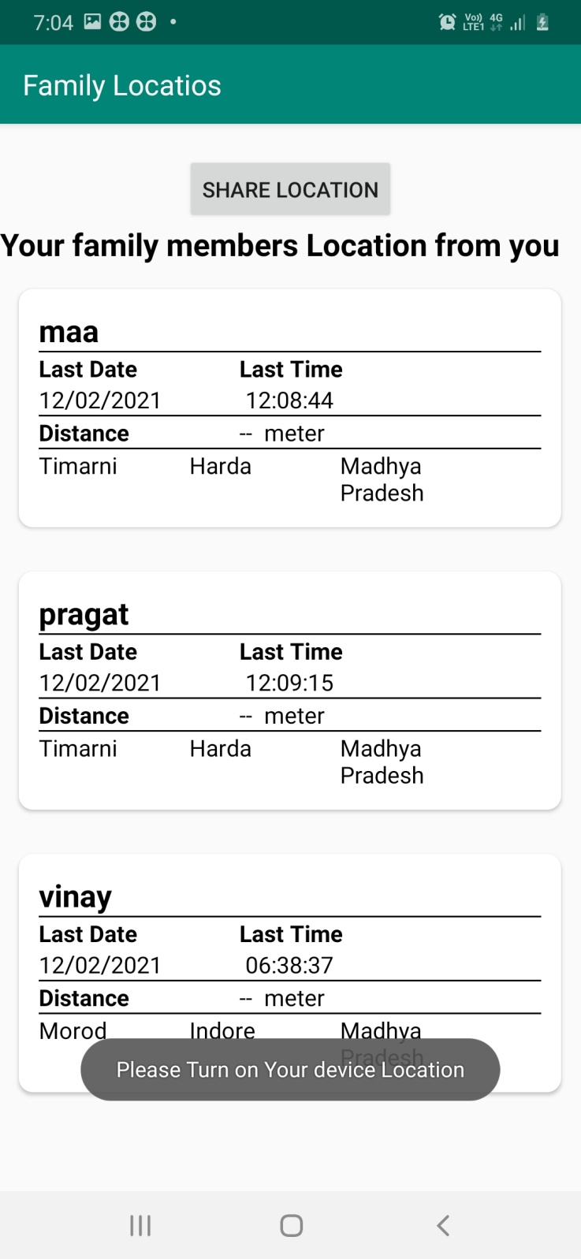

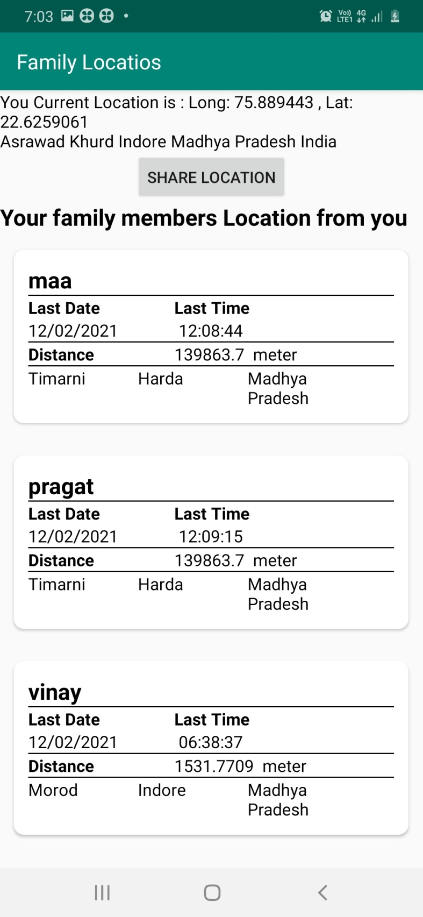

Stored User Location Data

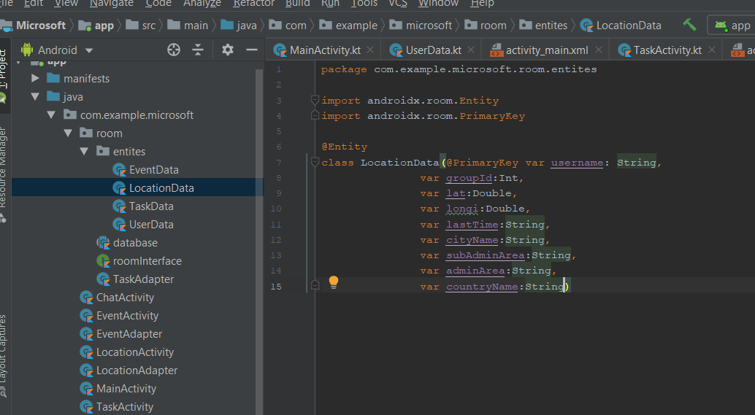

There are many features remaining like notification when any family member have distance is less than some threshold.

And Reminder Notification, where user get notification

of birthday and any special events.